|  |
| --- |
| Name: Dassanayake L D P |
| Student Reference Number:10569124 |



|  |  |  |
| --- | --- | --- |
| Module Code: **SOFT255SL** | Module Name: Software Engineering for the Internet using Java | |
| Coursework Title:  **Library Management System** | | |
| Deadline Date:2017-01-22 | | Member of staff responsible for coursework: |
| Programme: | | |
| Please note that University Academic Regulations are available under Rules and Regulations on the University website [www.plymouth.ac.uk/studenthandbook](http://www.plymouth.ac.uk/studenthandbook). | | |
| Group work:please list all names of all participants formally associated with this work and state whether the work was undertaken alone or as part of a team. Please note you may be required to identify individual responsibility for component parts.  ***We confirm that we have read and understood the Plymouth University regulations relating to Assessment Offences and that we are aware of the possible penalties for any breach of these regulations. We confirm that this is the independent work of the group.***  Signed on behalf of the group: | | |
| Individual assignment:***I confirm that I have read and understood the Plymouth University regulations relating to Assessment Offences and that I am aware of the possible penalties for any breach of these regulations. I confirm that this is my own independent work.***  Signed: | | |
| Use of translation software: failure to declare that translation software or a similar writing aid has been used will be treated as an assessment offence.  I *have used/not used translation software.  If used, please state name of software………………………………………………………………… | | |
| **Overall mark _____% Assessors Initials ______ Date_________** | | |

*Please delete as appropriateSci/ps/d:/students/cwkfrontcover/2013/14

Content

1. **Introduction.**
2. **Problem.**
3. Project aims.
4. Proposed System.
5. Scope.
6. Diagrams.
7. Object oriented principals included in the solution.
8. Software Interfaces.
9. Summary.

* **Library Management System**

**1. Introduction of the system**

Information Technology has changed the life’s of humans and made the lives easier by the many ways and by many kinds of applications. This project is interest with developing a Library Management system that using Object Oriented Programming. In this system the library management becomes more efficient & easier to use with its reliable system components.

**2.** **Problem**

In the current system all the transaction of books are done manually, So taking more time for a transaction like borrowing a book or returning a book and also for searching of books.

Even most of now a day Library systems are running in paper based environments this will effect on the storage, efficient and time.

Most Librarians have difficult in keep track of the data in the library.

Especially when trying to add new records, change records and delete records. So it is hard to Librarians to maintain records and provide efficient service to the members of the library.

3. Project aims

* Provide java object oriented based computerize solution for the given problem.
* Easy way of keep track of books in the library.
* Add new books update and delete them from few clicks.
* Without doing all of in a separately provide a way of doing all in one place.
* Provide easy way of registering new members.

4. Proposed System

Proposed system is computerize library system for the Librarian. All the details about the books members and librarians will be stored in a database rather than a paper based system. With this application user (librarian) can easily work with the records and details of the books, members and librarians. And avoid time consuming and less effective methods of using paper based system for record keeping.

5. Scope

The different areas we can use this application are:

* Any education or office institute can use this application to provide a better service to members of the organization.
* Books publisher or supplier can use this software to easily provide efficient services to the costumers.

6. Diagrams

UML Class diagram

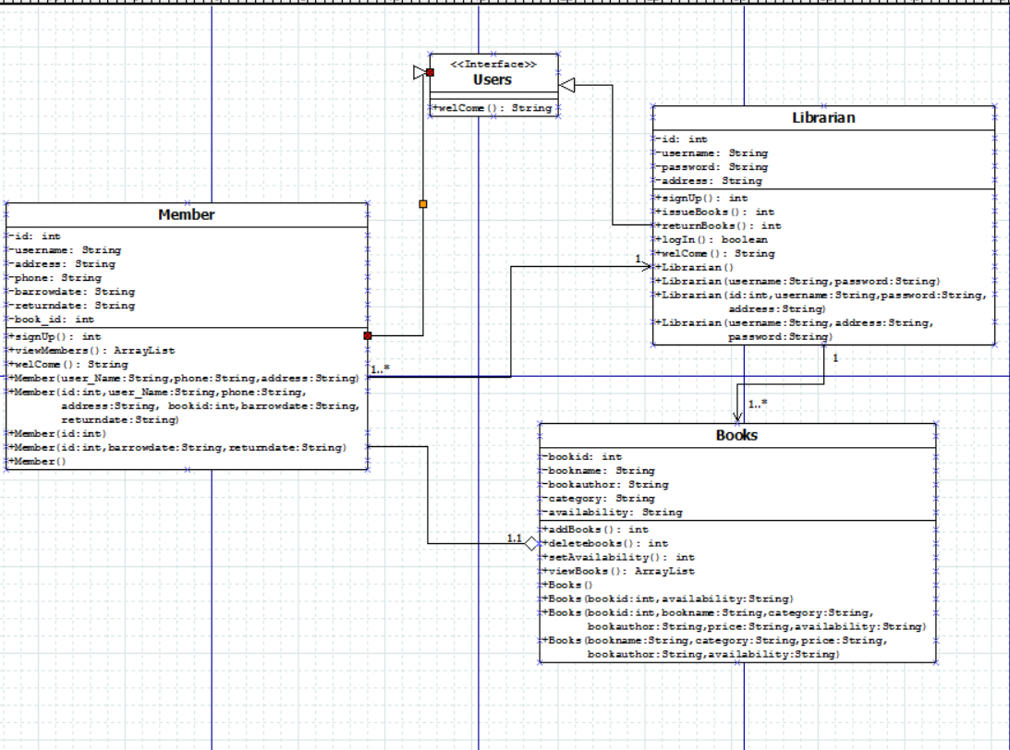

In here Librarian and member are sub classes of the Users interface. And showing all attributes and the behaviours of the classes. Including relations among them.

* Use case diagram

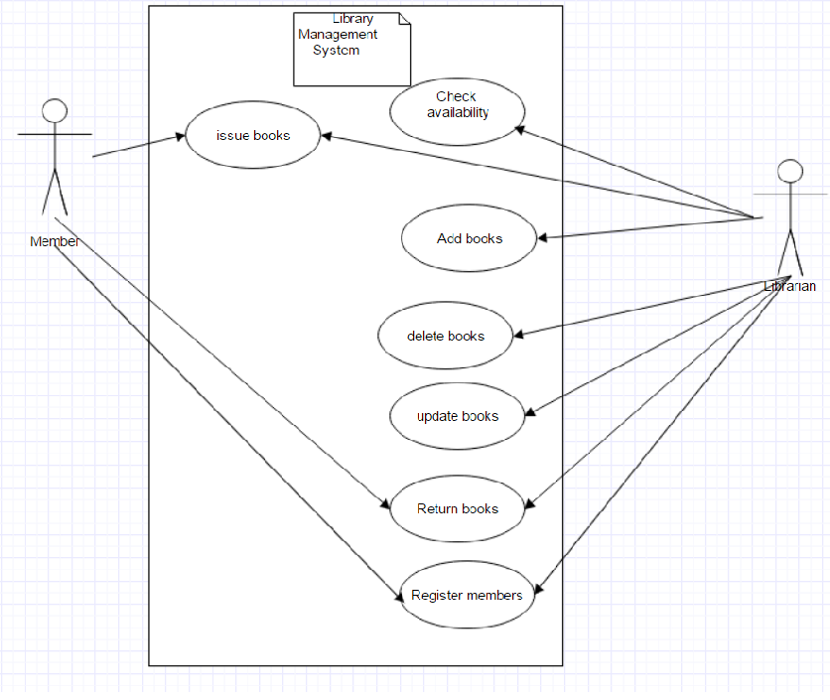

7. Object oriented principals included in the solution.

1. Objects and classes

2. Inheritance.

3. Polymorphism.

4. Encapsulation.

8. Software Interfaces

8.1 Login

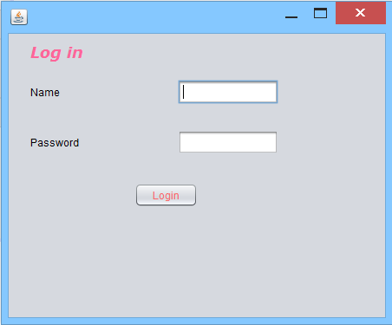

After a successful log in user will be sent to the Librarian Penal.

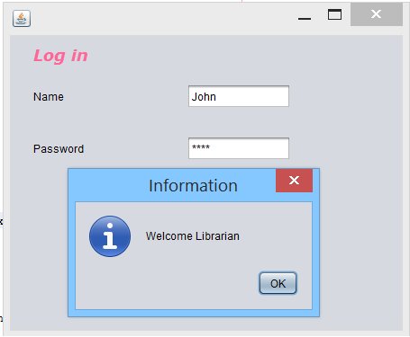

8.2 Librarian Penal

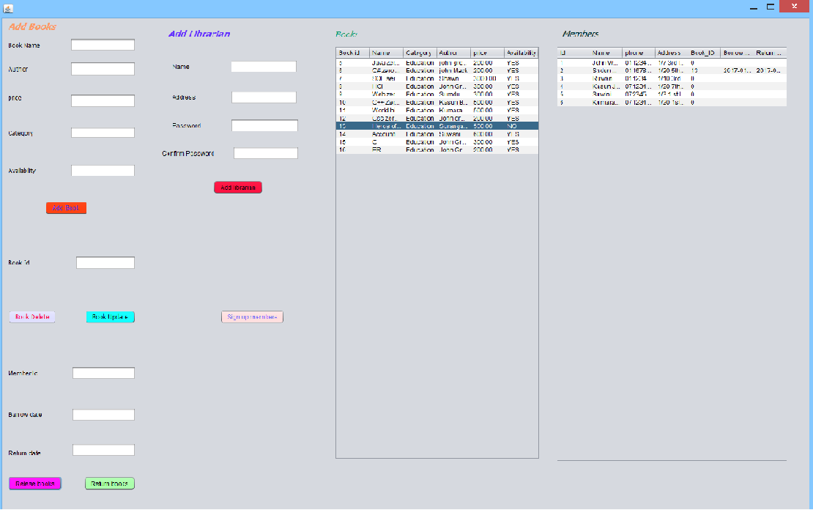One panel with all the Features a Librarian need. Providing simpler way of performing tasks rather than choosing multiple forms and panels.

8.3 Adding new book

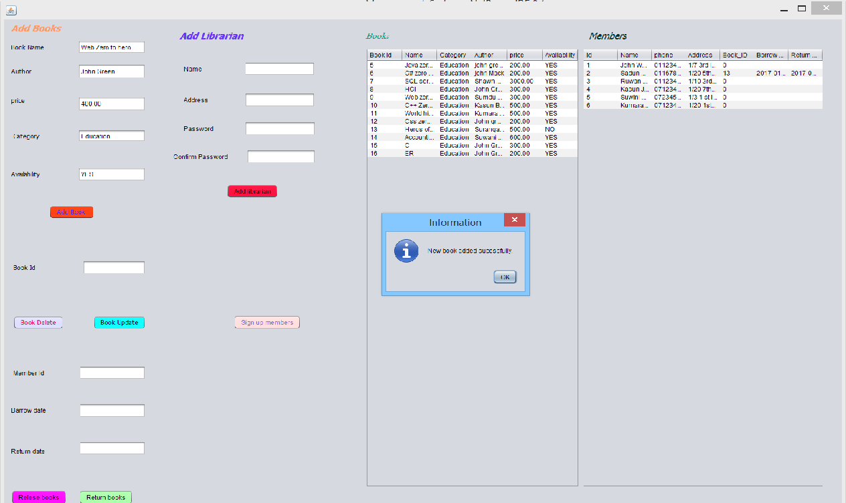

New book can be added without a hard paper work.

Which previously added in the paper based system.

8.4 Delete a book.

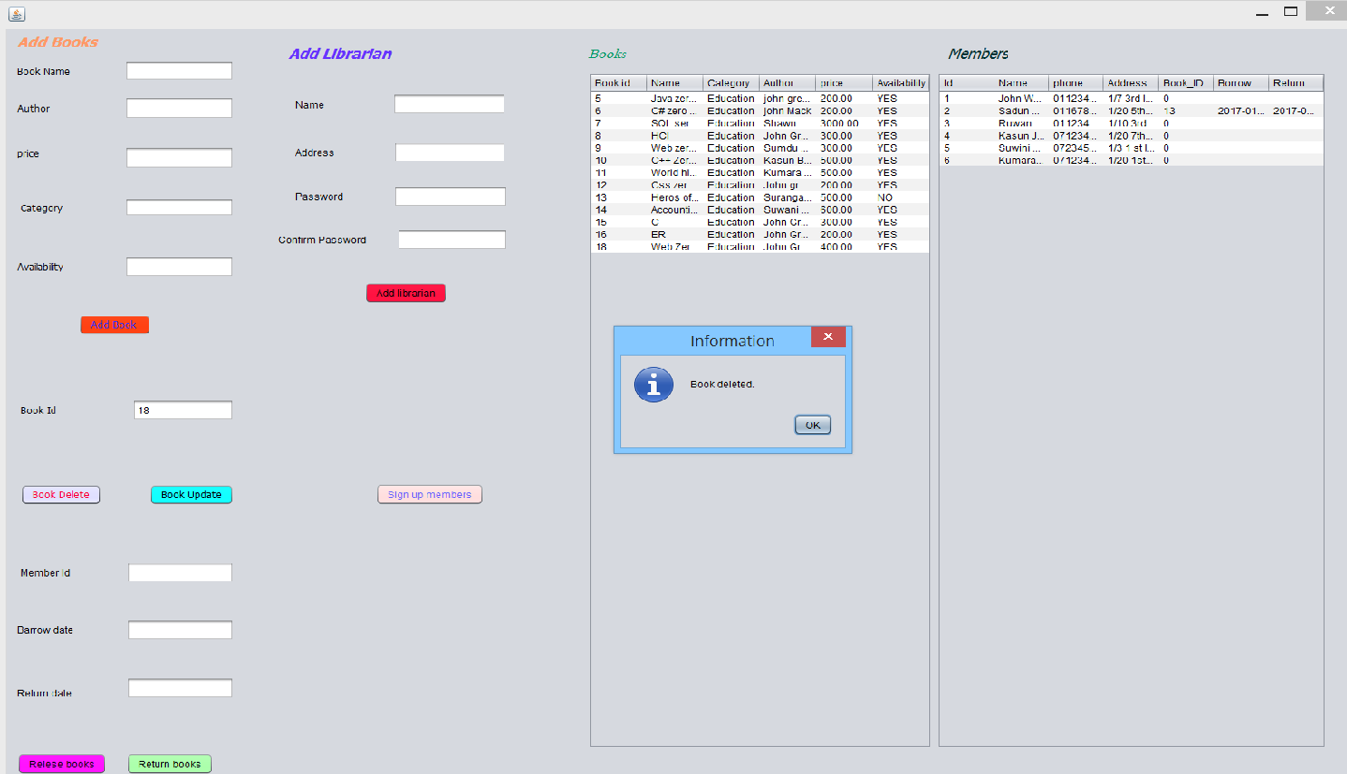

A book can be delete easily without a doing all the paper work and finding files which are ages old. It would take many times to even find. This would result a massive time consuming task.

8.5 Issuing books.

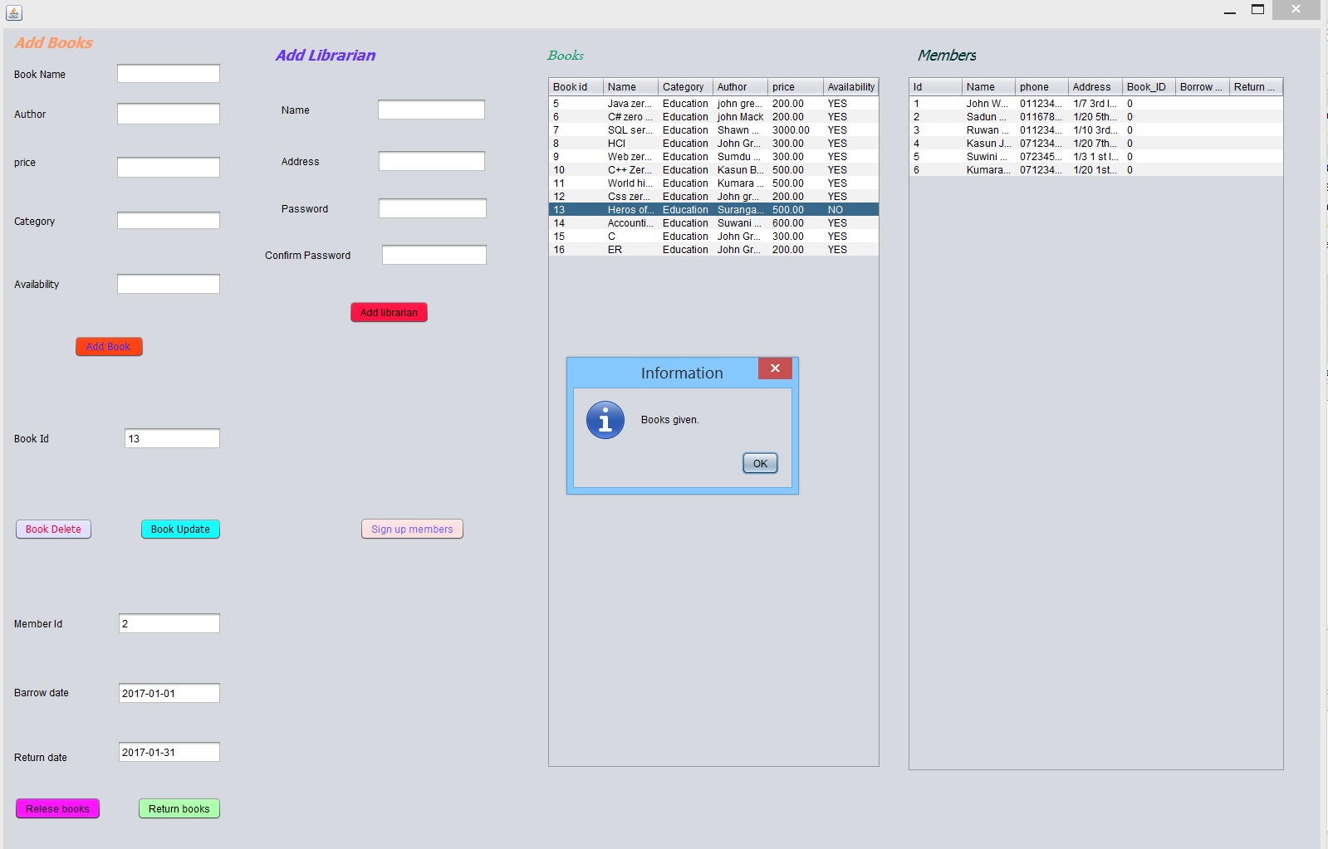

When releasing a book to a member it can done by easily without a writing in a paper and cards. Just insert book id, member id, date barrowed date returning.

8.6 Returning Book

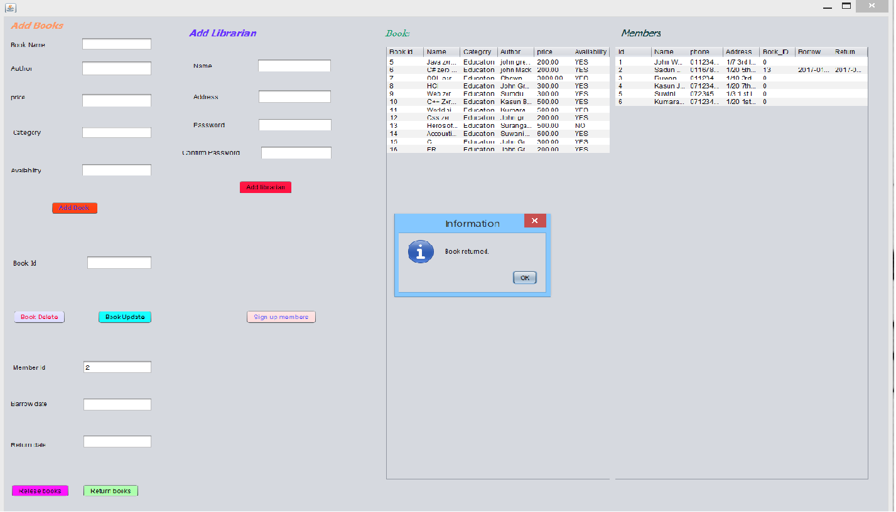

When book returned there will be no need to find the file of the issued books or book details files. Just insert the Member id of the member who took the book.

8.7 Adding Librarian

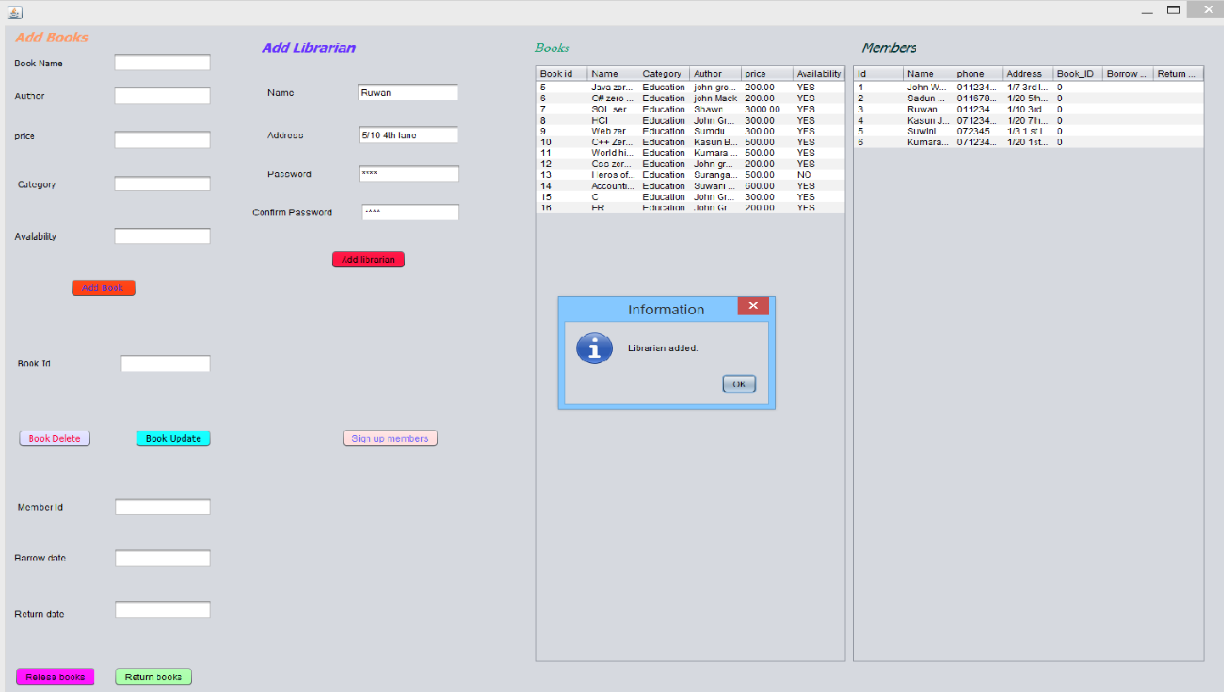

Without filing papers and forms a new librarian can add without a problem.

8.8 Adding a new member.

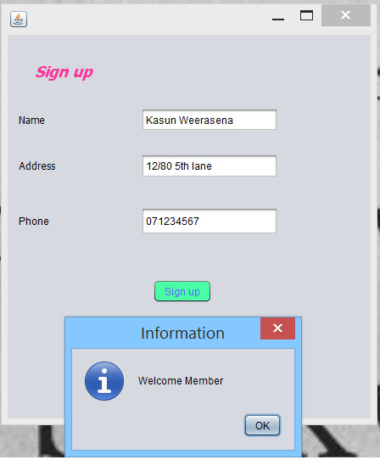

9. Summary

The Library management system needs to be computerized to reduce the time consuming and to increase the efficiency. This Library management system will be a computerized management system developed to maintain all the daily work of library done by Librarian. Library management systems are designed to store all the information about books and members. The main focus of this project is to reduce the time consuming and higher the efficiency.

Plagiarism check

